Project: Moffat Bay Marina Website | Blue Team Moffat Bay Marina Website Test Cases
Course: CSD460 – Capstone in Software Development | Jonah Aney, Justin Marucci, Nardos Gabremedhin, Amanda Wedergren
Description: Website for Moffat Bay Marina to accept reservations for slips
Date: February 15, 2026
To complete the test case plan, fill out the information for Project, Course, Description and Date in the header below.
.
TABLE OF CONTENTS
Estimated cost formula displays correct cost 3
Add a new boat 4
Login required 5
Field entry requirements 7

For each test, the developer should: provide a test description, a test objective, the developer name and date tested. For each step, fill out the actions to be taken and describe the expected results, and indicate yes or no for each step depending upon the result. The peer tester should provide their name, date tested, indicate yes or no for each step depending upon the result, and a screenshot (thumbnail) of the result.

Test 1 | Estimated cost formula displays correct cost
 | Test Objective: verifies the cost calculator works correctly | Developer: Amanda Wedergren  Date tested: 2026/02/08 | Peer tester: Jonah Aney  Date tested: 2026/02/15
Step | Action | Expected results: | Developer pass/fail | Tester pass/fail  + Screenshot
1 | Enter a start and end date | System should force the end date to be at least one month away | pass | yes  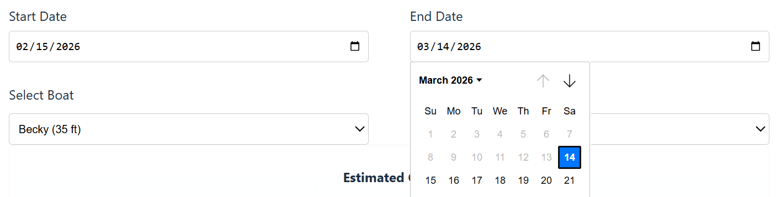
2 | Select a saved boat | Slip size should auto select the shortest slip size to fit the boat length | pass | yes  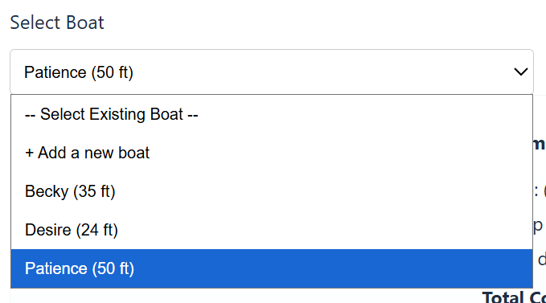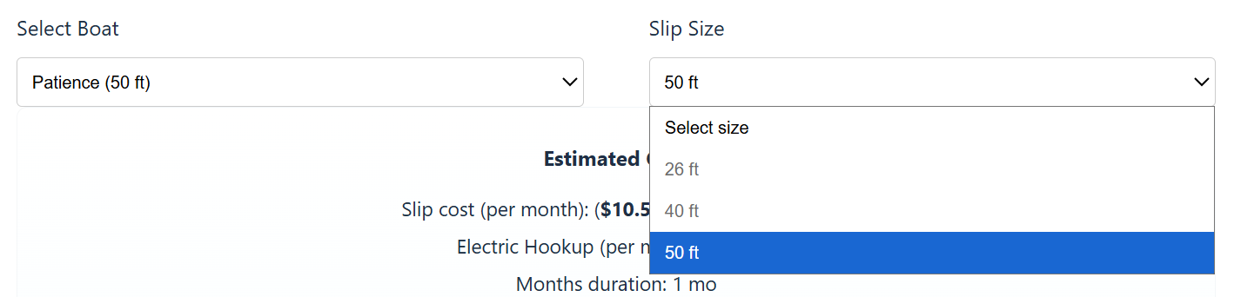
3 | Check cost calculator | Calculator will display the accurate cost of the dates and boat size selected | pass | yes  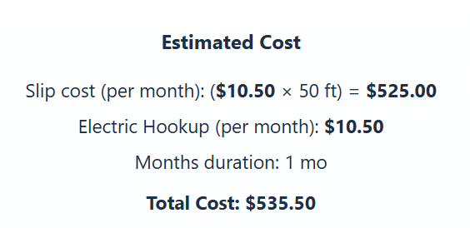
Comments | The cost formula displays correctly. It even correctly calculates the total cost of the reservation, even when the reservation is for more than 1 month time.

Test 2 | Add a new boat
 | Test Objective: Confirm the system successfully adds a boat to the user profile and database | Developer: Amanda Wedergren  Date tested: 2026/02/08 | Peer tester: Jonah Aney  Date tested: 2026/02/15
Step | Action | Expected results: | Developer pass/fail | Tester pass/fail
1 | Choose the “Add a boat” option in the drop down menu | Entry fields for boat name and boat length should appear | pass | yes  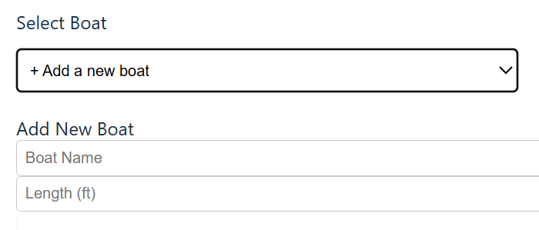
2 | Enter a boat name and boat length in feet | “Add boat” should appear once both fields have been filled out | pass | yes  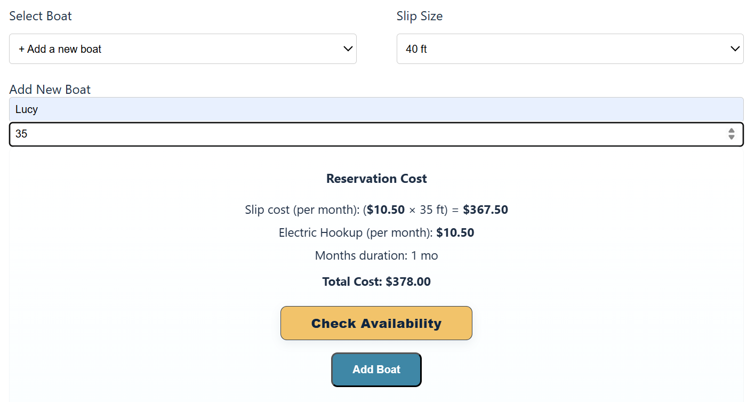
3 | Click “Add boat” button | User will have a boat in their saved boats list. (Viewable in the drop down or on the My Account page) database can confirm boat was added) | pass | yes  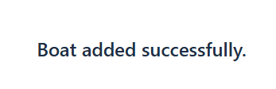  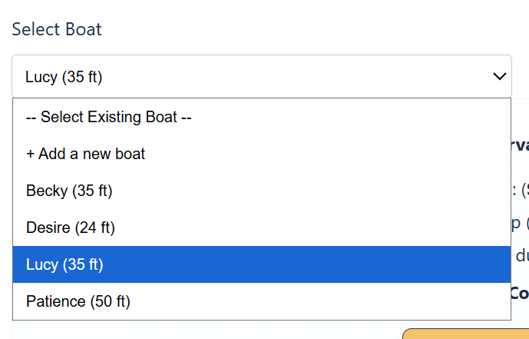
Comments | The user is able to successfully add a boat to their account. By adding the boat to the account, it makes it easier to start the reservation process for any future needs

Test 3 | Login required
 | Test Objective: Confirm the system requires a user to login (or create an account) before they can make a reservation | Developer: Amanda Wedergren  Date tested: 2026/02/08 | Peer tester: Jonah Aney  Date tested: 2026/02/15
Step | Action | Expected results: | Developer pass/fail | Tester pass/fail
1 | Go to the “Reservations” link in the menu | The system should display an info page about reservations | pass | yes  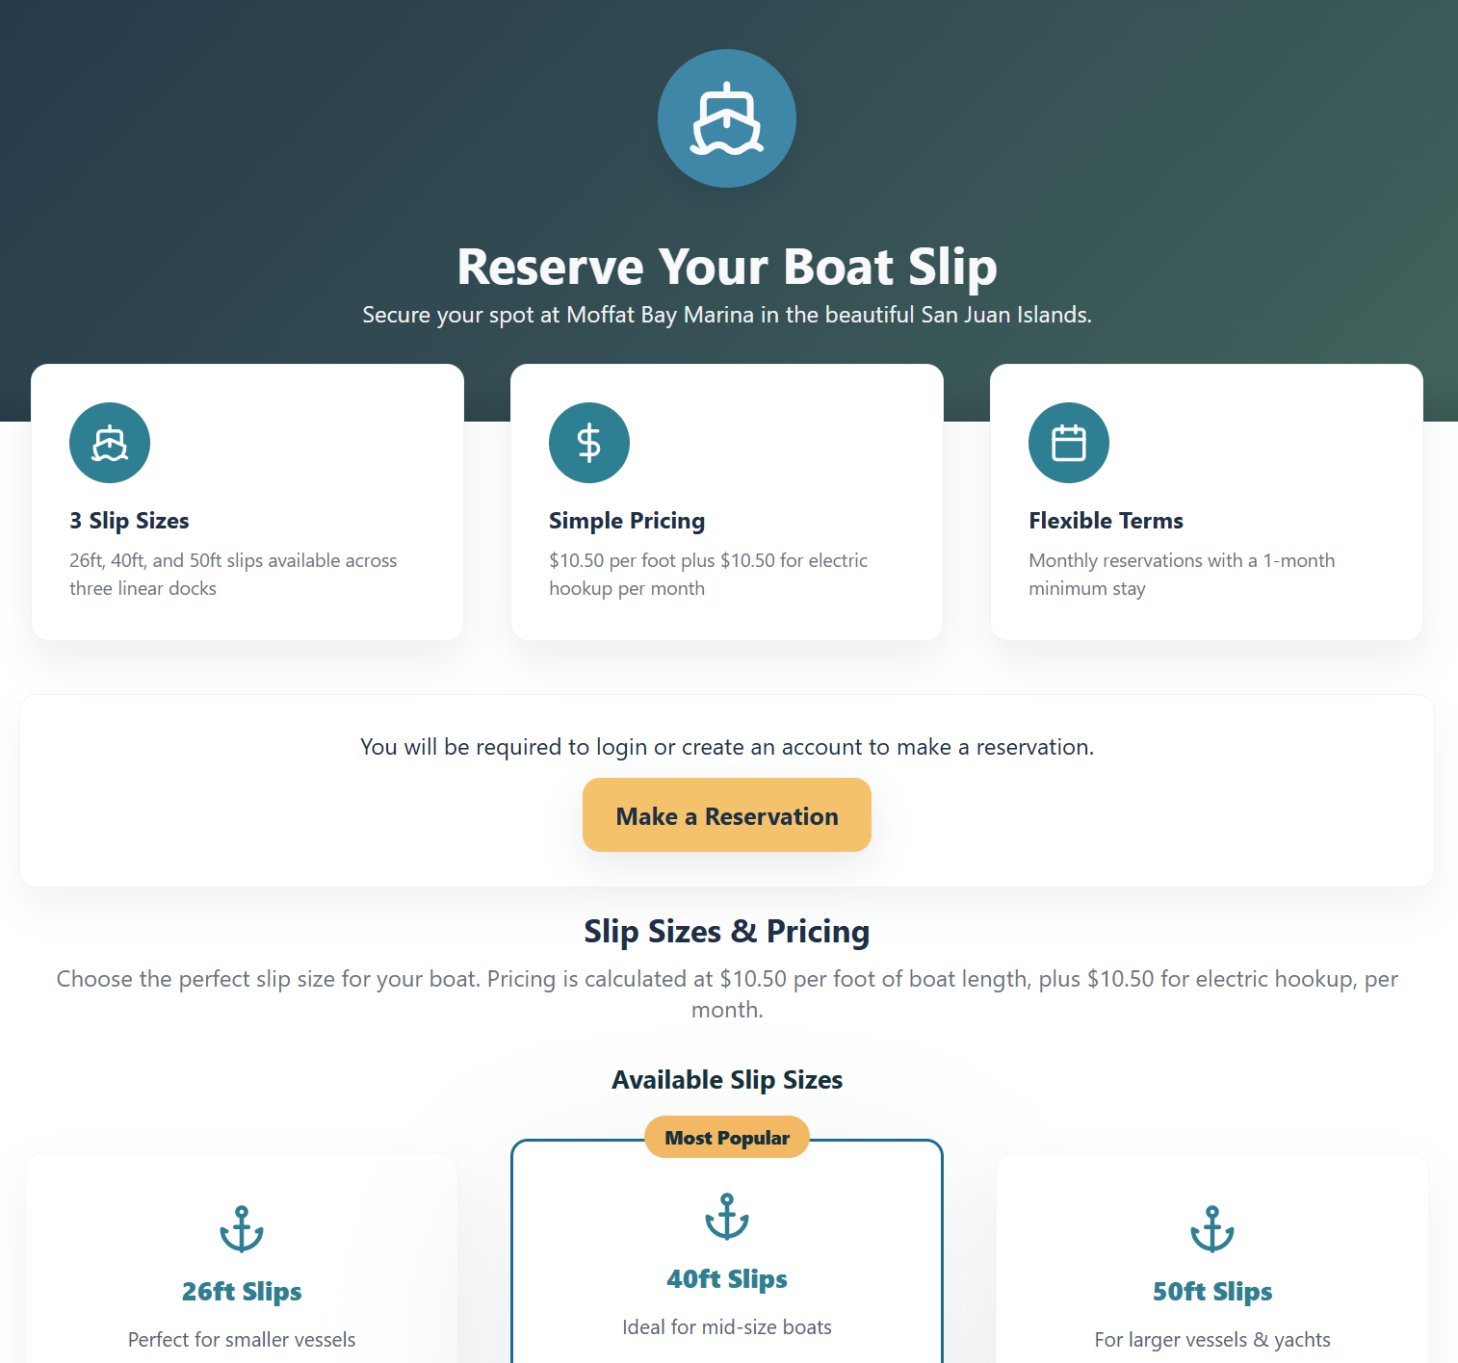
2 | Click on the “Make a Reservation” button on the info page | Should require the user to login to their account (or create one if they do not have one) | pass | yes  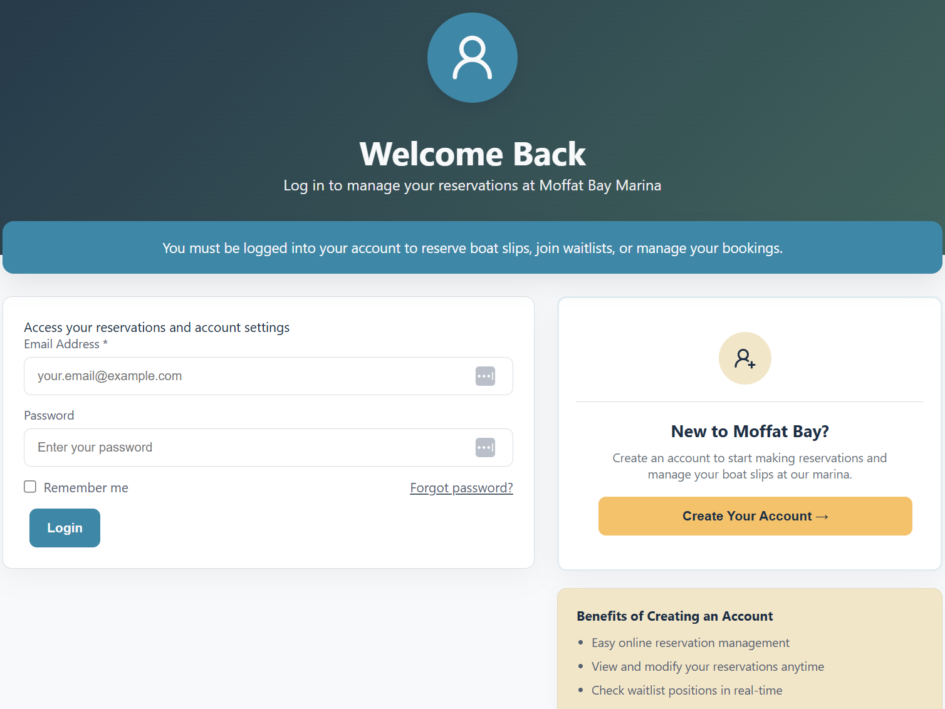
3 | Login as a user from the database | System should direct user to the reservation page if successfully logged in | pass | yes  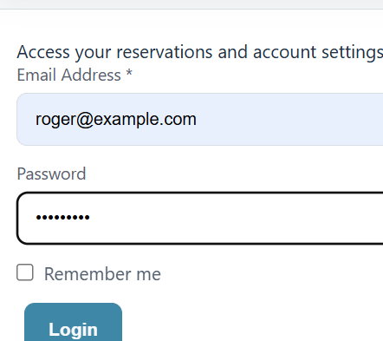  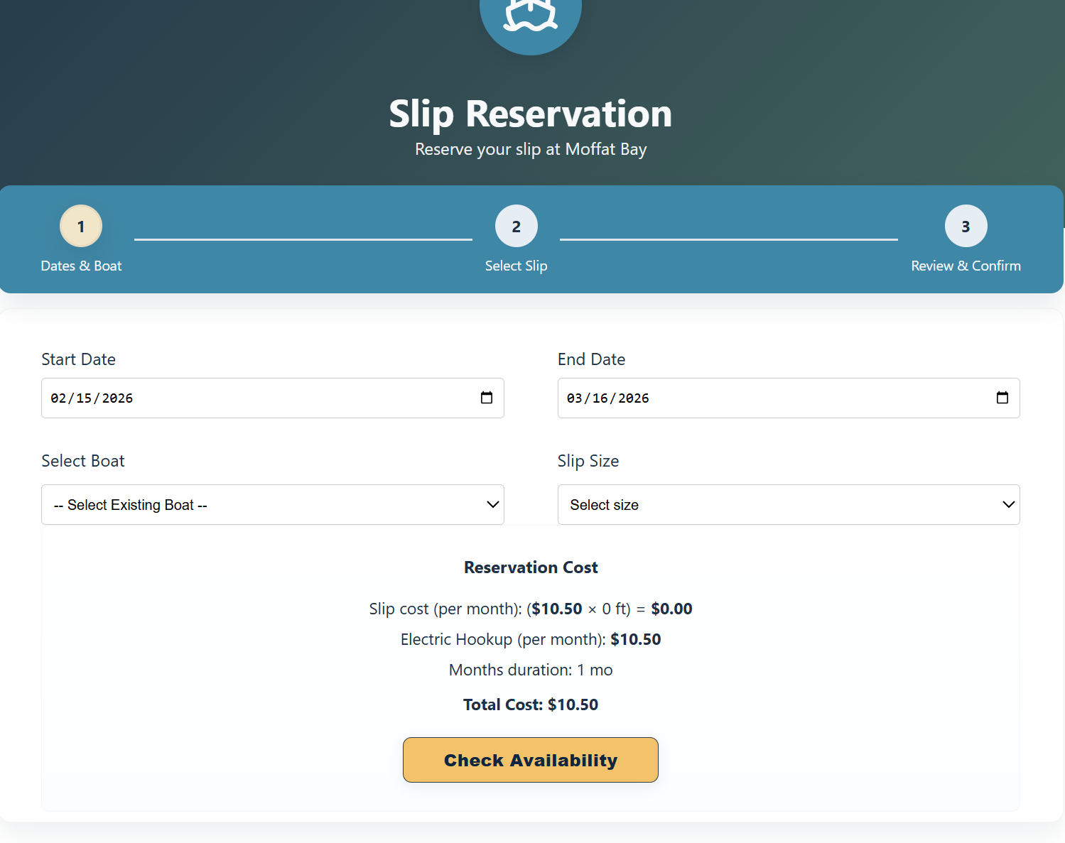
Comments | The system requires the user to login to their account in order to make a reservation. If the user does not have an account, they can make an account before starting the reservation process. The flow works nicely and the system prompts the user as required.

Test 4 | Field entry requirements
 | Test Objective: confirm that the reservation fields must all be complete before a slip availability can be determined | Developer: Amanda Wedergren  Date tested: 2026/02/08 | Peer tester: Jonah Aney  Date tested: 2026/02/15
Step | Action | Expected results: | Developer pass/fail | Tester pass/fail
1 | Try to enter an end date that is not at least one month after the start date | System should not allow a user to choose any less than one month after the start date | pass | yes  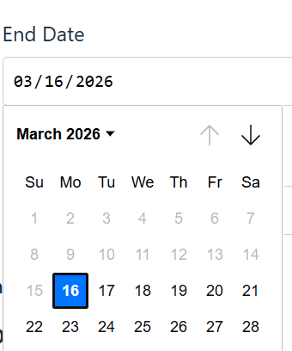
2 | Try to click “Check Availability” without choosing a boat | System should display an error/warning message that all fields should be filled out | pass | yes  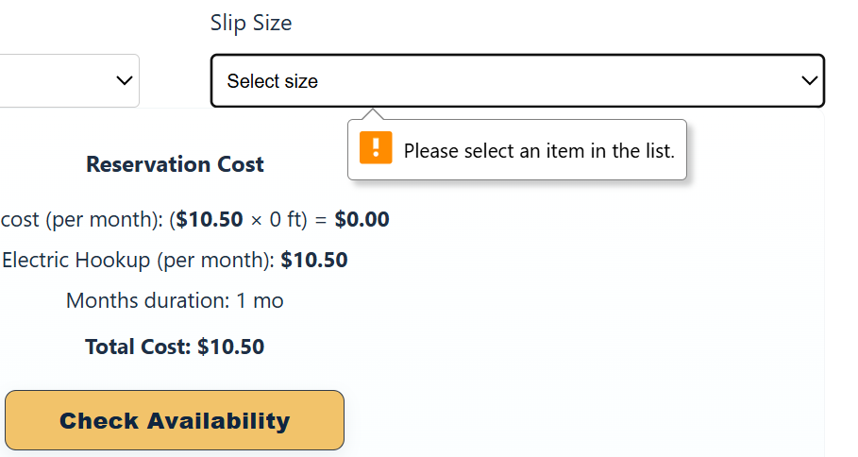
3 | Try to see availability without selecting a boat | Should display an error message to select a boat | pass | yes  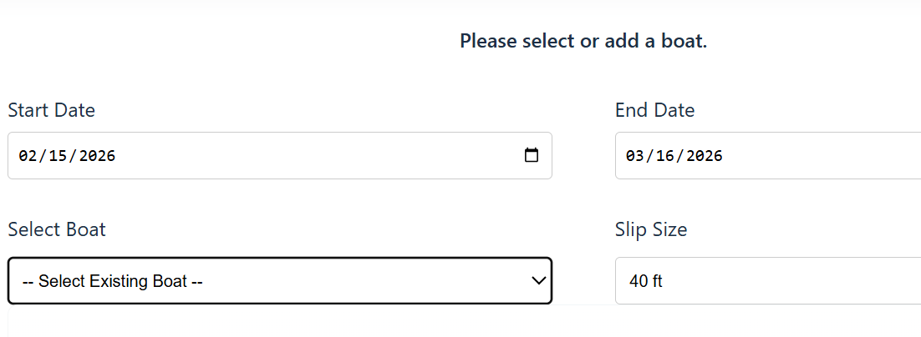
Comments | The system forces the user to enter data into all fields before they are able to see availability for slips. This makes sure that all required data is obtained before displaying any options. The errors and warning display as expected.

